Answer Key
1.
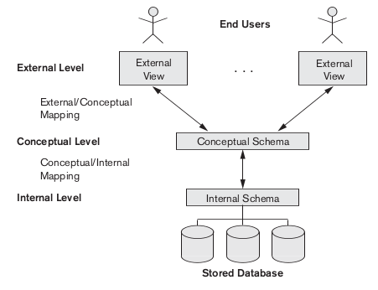

2.
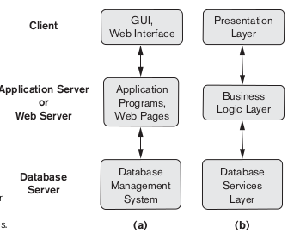

3. CAR (state,Reg #,serial no,Make,Model,Year)
1)how many super keys are there for this schema
2 ^{m-1}=2 ⁵=32
2)which are they,
{state,reg #},{state ,serial no},{state,make},{state,model},{State,Year}............
3) Identify a super key which is not a primary
{Serial no,Make}
4.Data security :-advances in encription and decryption technology
Data compression:-to transfer large amount of data from servers to clients over wired and wireless networks.
5.a) Violates both the key constraint and referential integrity. Violates the key constraint
because there already exists a DEPARTMENT tuple with DNUMBER=4. We may enforce
this constraint by: (i) rejecting the insertion, or (ii) changing the value of DNUMBER
in the new DEPARTMENT tuple to a value that does not violate the key constraint. Violates
referential integrity because MGRSSN='943775543' and there is no tuple in the
EMPLOYEE relation with SSN='943775543'. We may enforce the constraint by: (i)
rejecting the insertion, (ii) changing the value of MGRSSN to an existing SSN value in
EMPLOYEE, or (iii) inserting a new EMPLOYEE tuple with SSN='943775543'.
b) Violates referential integrity because DNUM=2 and there is no tuple in the DEPARTMENT relation with DNUMBER=2. We may enforce the constraint by: (i) rejecting the insertion of the new PROJECT tuple, (ii) changing the value of DNUM in the new PROJECT tuple to an existing DNUMBER value in the DEPARTMENT relation, or (iii)inserting a new DEPARTMENT tuple with DNUMBER=2.
c) Violates referential integrity because several tuples exist in the WORKS_ON,
DEPENDENT, DEPARTMENT, and EMPLOYEE relations that reference the tuple being
deleted from EMPLOYEE. We may enforce the constraint by: (i) rejecting the deletion, or
(ii) deleting all tuples in the WORKS_ON, DEPENDENT, DEPARTMENT, and EMPLOYEE
relations whose values for ESSN, ESSN, MGRSSN, and SUPERSSN, respectively, is equal
to'987654321'.
d) Violates referential integrity because the new value of SUPERSSN='943775543' and
there is no tuple in the EMPLOYEE relation with SSN='943775543'. We may enforce the
constraint by: (i) rejecting the deletion, or (ii) inserting a new EMPLOYEE tuple with
SSN='943775543'.
6.The schema has the following four foreign keys:
A. the attribute SSN of relation ENROLL that references relation STUDENT,
B. the attribute Course# in relation ENROLL that references relation COURSE,
C. the attribute Course# in relation BOOK_ADOPTION that references relation COURSE, and
D. the attribute Book_ISBN of relation BOOK_ADOPTION that references relation TEXT.

7.numeric data,character string, Bit-string, Boolean, data,time,time stamp,Interval
8. Yes, it is a valid combination, But no need of specifying “NOT NULL” as PRIMARY KEY constraint itself enforces the “NOT NULL” condition.
9. SELECT E.Frame,E.Minit,E.Lname
FROM Employee E,Works_on W,PROJECT P
WHERE E.Dno= 5 and E.ssn=W.Essn and W.Pno =P.Pnumber and P.Pname =’Product X’ and W.hours >10;
10. James E Borg has SSn 888665555 and has no superviser. But he is the superviser of 2 people having SSn 333445555, 987654321. So these rows will be affected due to violation of referential integrity constraint.

